Contents

Students Information Application Design

RequirementS 3

Collecting Students information 3

Testing the Students Data application 3

Business VALIDATIONS 3

Page Look and feel 3

Logic implementation 4

unit test cases 5

Technical things covered as part of the project 6

Techstack 6

Coding concepts 6

# RequirementS

1. Give high-level introduction to the project.

## Collecting Students information

* Give provision to users to enter student’s information.
* Selection of subjects and days is a limited choice.
* In the second page give provision to select additional data
* Display all students’ information dynamically upon submitting.

## Testing the Students Data application

* Enter student’s information.
* Select only specified number of subjects and days.
* Click on “next” and enter remaining data and then submit to see all the collected data dynamically.
* By clicking “next student” enter next student details.

1. Describe the scope of functionality that this document covers.
2. List the documents that are direct inputs to this document or are related documents the reader of this document should also review.
3. List each unique term introduced or referenced in this document using the style Heading 4 – no numbering. If you have a master glossary, refer the reader to the glossary document, but list the terms with no definition.

# Business VALIDATIONS

* User needs to enter name, surname and select CGPA level, days and subjects.
* Student First name is mandatory.
* In the next page select Birth Date and Gender.
* Birth date cannot be future date.
* Upon submit all the student details will come.
* Clicking on Next Student will show an alert that user going to enter another student details.

# Page Look and feel

First Page: “students_First.html”

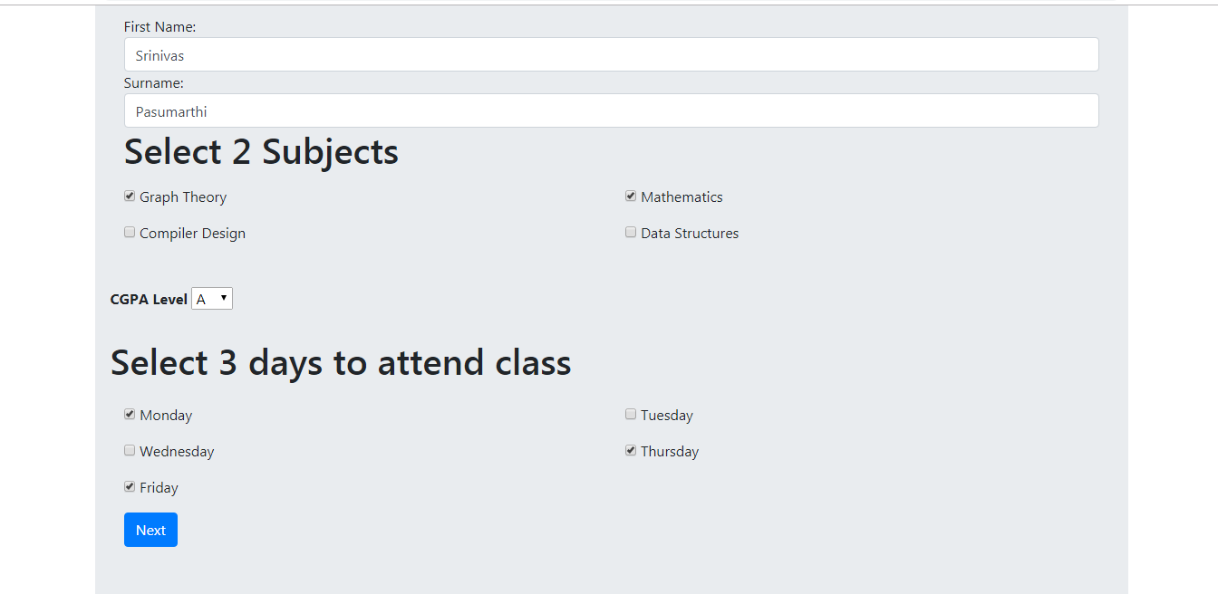

Second Page: “subj_studs_info.html”

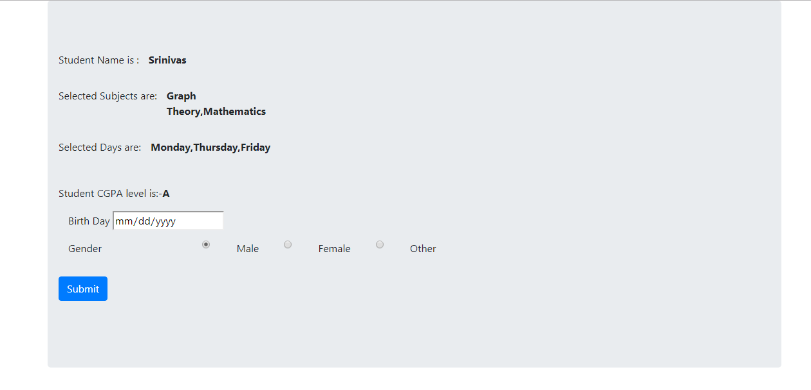

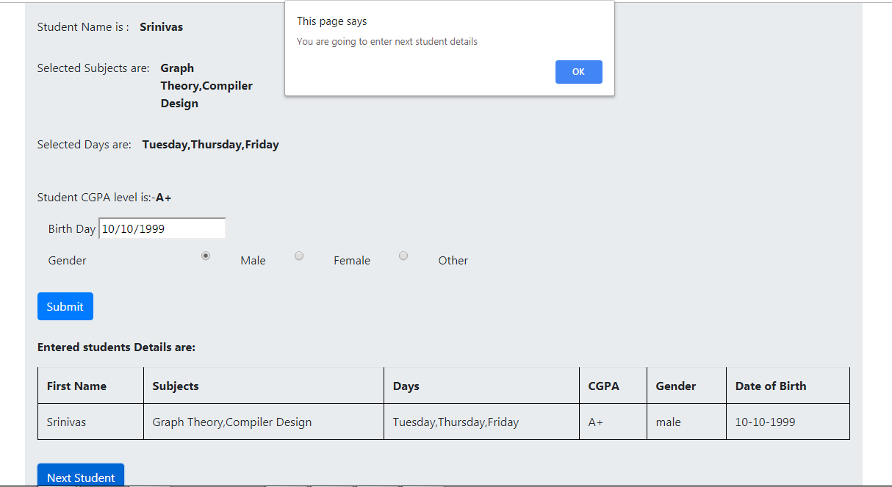

# Logic implementation

Logic for birth date validation:

var birthDate = document.getElementById("dtime").value;

birthDate = new Date(birthDate);

var todayDate=new Date() ;

console.log(birthDate);

console.log(todayDate);

if(birthDate >todayDate)

{

alert("Birth date is future date");

return false;

}

Logic to enable “Next” button after selecting exact number of subjects and days:

$(".subject,.days").click(function () {

var days = $(".days");

var subject = $(".subject");

var subject_ar = [];

var days_ar = [];

subject.each(function (key, value) {

// console.log($(this));

if ($(this).is(":checked")) {

subject_ar.push($(this).val());

}

});

localStorage.setItem("subject_ar", subject_ar);

days.each(function (key, value) {

if ($(this).is(":checked")) {

days_ar.push($(this).val());

}

});

localStorage.setItem("days_ar", days_ar);

if (subject_ar.length == 2 && days_ar.length == 3) {

$("#Save").css({ display: 'block' });

} else {

$("#Save").css({ display: 'none' });

}

# unit test cases

1. Describe how this design will impact current users of the product (in terms of changes in their day-to-day use of the product. You can reference the process description in the Solution Analysis section as appropriate.

|  |  |  |
| --- | --- | --- |
| **S.No** | **Case** | **Result** |
| 1 | Try to enter student data without first name | Alert message will come and page won’t get forwarded to next page. |
| 2 | Enter birthdate as future date | An alert message will come and table won’t get displayed. |
| 3 | Enter all the details and click on submit | Note that date field format in table changed to DD-MM-YYYY |

1. Describe the nature of any dependencies that other products or pending features have on this enhancement.

# Technical things covered as part of the project

## Techstack

* HTML5, JavaScript, Bootstrap, Jquery, CSS

## Coding concepts

* HTML Page creation
* In JavaScript Arrays, JSON objects, Array of JSON objects, Date field APIs, Local storage API, Array APIs etc.